- Install Solidworks correctly to ensure that Solidworks Cam can run normally;
- Copy Carvera-3axis.ctl and Carvera-3axis.lng to the directory of C:\ProgramData\SOLIDWORKS\SOLIDWORKS CAM 20XX\Posts\Mill;
- Create a CAM project, edit machine partmeters;
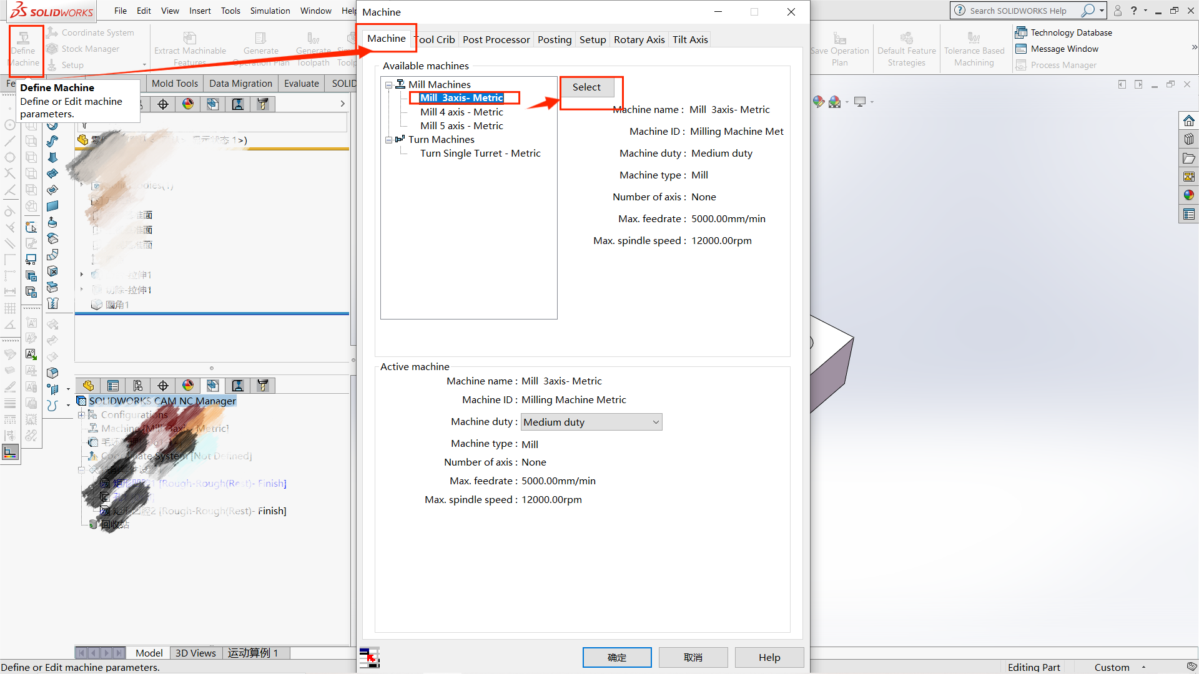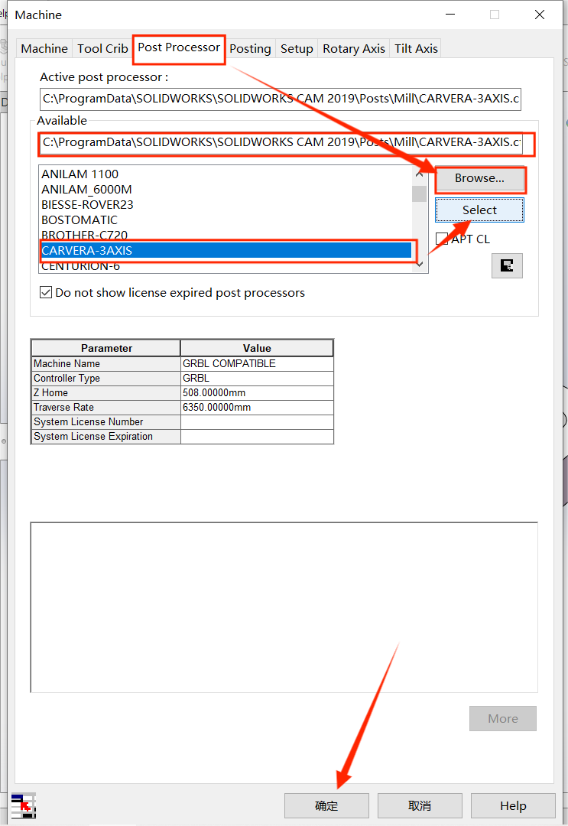
- Generate Gcode to the directory of C:\ProgramFiles(x86)\CarveraController\gcodes ;